AI-POWERED REAL-TIME BATTERY FITNESS
ASSESSMENT PLATFORM
MACRO PROJECT – I
Milestone 2 – Implementation & Functional Exercise Assessment
Submitted By: -
Aakanksha Vidushi Pandey (BTAI25O1001)
Dhruv Urmaliya (BTAI25O1052)
Under the Guidance of: -
Dr. Neelam Arya

CENTRE FOR ARTIFICIAL INTELLIGENCE
Madhav Institute of Technology & Science
Gwalior – 474005 (MP)
July – December 2026

1. Milestone 2 Overview
Milestone 1 established the technical foundation of this project: a live webcam-to-pose pipeline using YOLO26-Pose to detect 17 body key points and an initial joint-angle calculation, with the elbow angle validated. Milestone 2 extends this foundation towards functional assessment analysis by implementing assessment-specific movement interpretation for the Phase 1 tests: Sit-Ups, Sit & Reach, and Vertical Jump.
Milestone 1 = Technical Foundation → Milestone 2 = Assessment-Specific Movement Analysis

2. Milestone 1 Baseline
Component | Milestone 1 | Milestone 2
Webcam/OpenCV | Working | Continue
YOLO26-Pose | Working | Continue
Key points | 17 detected | Exercise analysis
Joint Angle | Initial (elbow validated) | Extend to hip, knee
Sit-ups | Pending | Movement/state analysis
Sit & reach | Pending | Posture and reach movement analysis
Vertical Jump | Pending | Movement phase analysis
Repetition Counting | Pending | Sit-up Implement
Database | Design stage | Future milestone

3. Objectives
- Implement Sit-Up movement/state detection using relevant body key points and joint-angle analysis.
- Implement transition-based repetition counting for Sit-Ups.
- Extend the pose-analysis pipeline for Sit & Reach using relevant posture, joint-angle, and wrist-position features.
- Explore movement phases relevant to Vertical Jump using body key points and joint-angle changes.
- Continue confidence filtering at threshold 0.5.
- Validate assessment-specific thresholds and movement features experimentally rather than assuming fixed values.

4. System Architecture
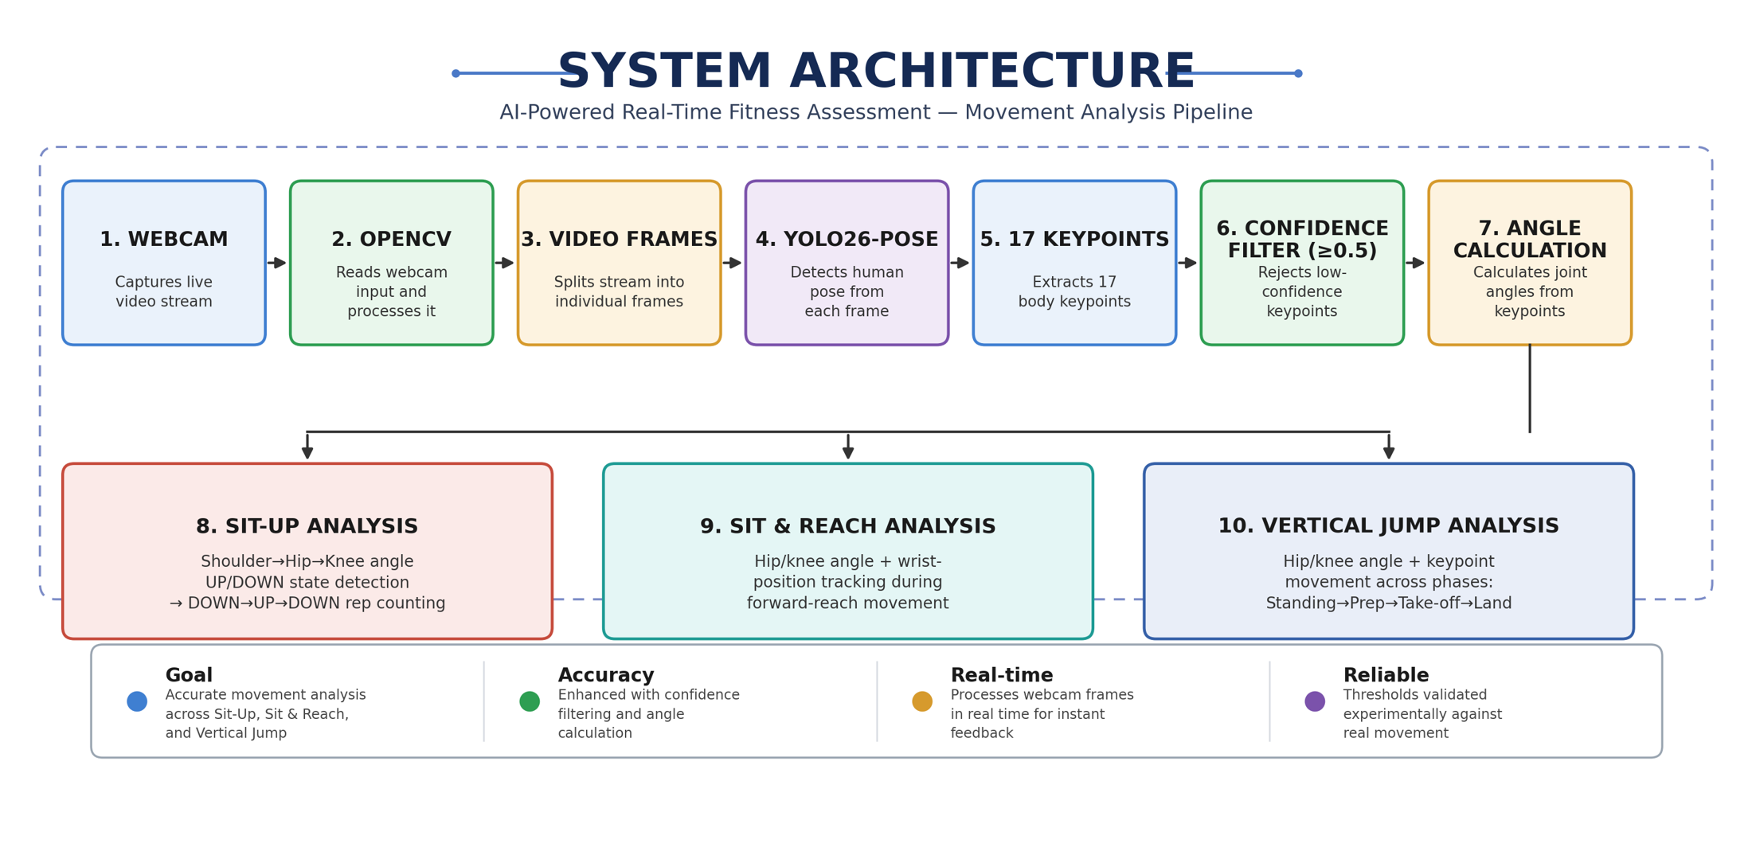

5. Webcam and OpenCV Implementation
cap = cv2.VideoCapture(0)
ret, frame = cap.read()
cv2.imshow('Live Feed', frame)
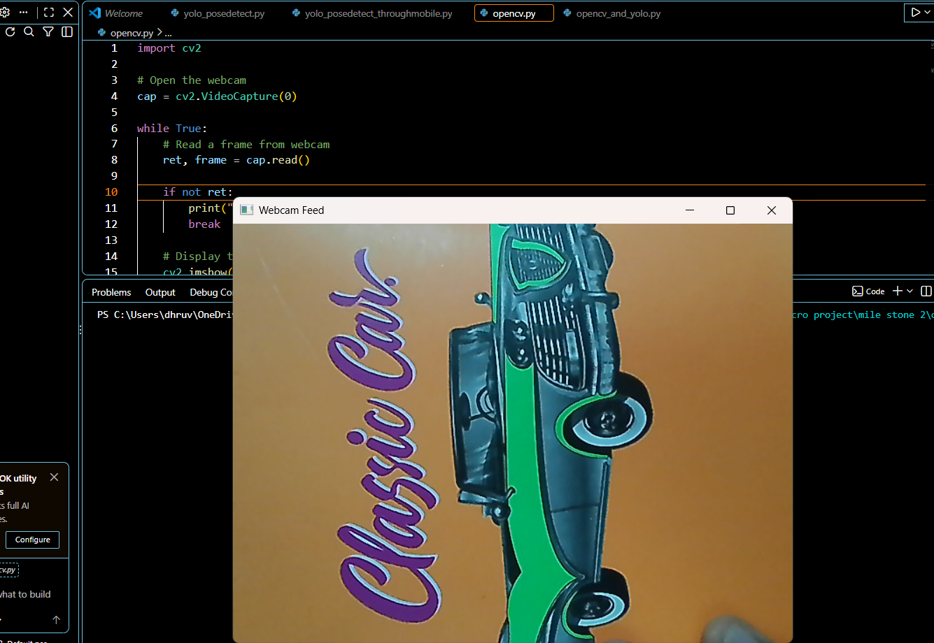
Figure 1: Live webcam feed captured using OpenCV
Confirms the video capture stage (carried over from Milestone 1) is active and feeding frames into the pipeline.

6. YOLO26-Pose Integration
model = YOLO("yolo26n-pose.pt")
results = model(frame)
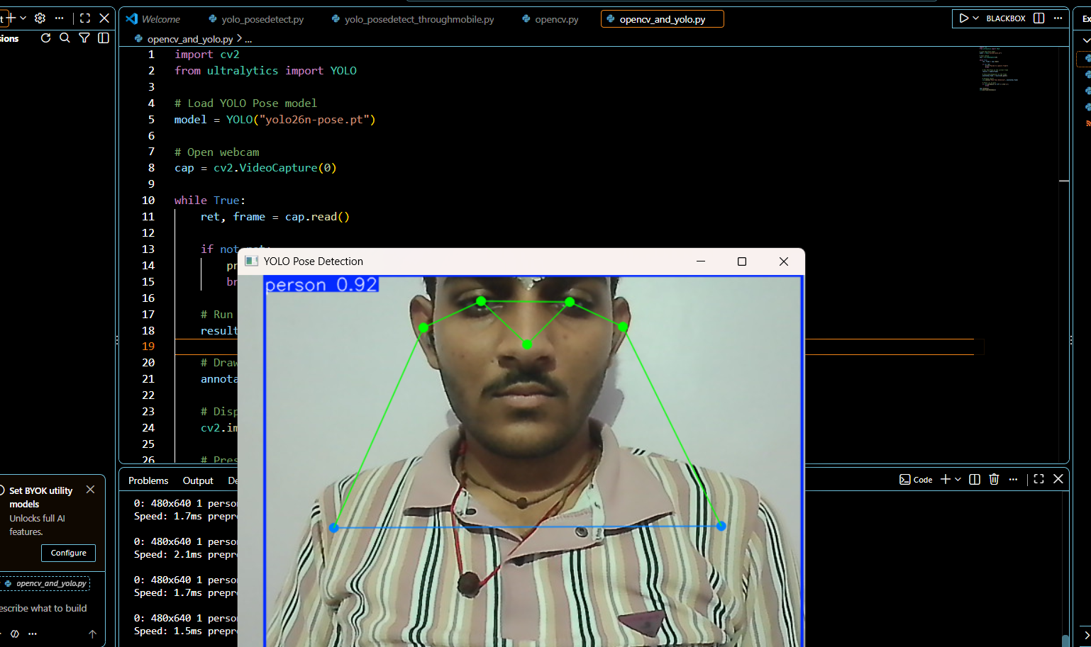
Figure 2: Real-time human pose detection using YOLO26-Pose.
Shows the model detecting the 17-keypoint skeleton on a live frame in real time.

7. Key point Extraction
YOLO26-Pose returns 17 body key points per person, each as (x-coordinate, y-coordinate, confidence). Keypoints with confidence below 0.5 are discarded before use, as established in Milestone 1.

8. Joint-Angle Calculation
θ = arccos( (BA · BC) / (|BA| × |BC|) )
This angle is required because YOLO26-Pose returns coordinate only; the angle at a joint is what allows the system to classify a body position as UP or DOWN. The elbow-angle case was validated in Milestone 1 and the same mathematical approach is now extended to assessment-specific joints, including hip and knee angles, depending on the movement being analysed.

9. Sit-up State Detection
Shoulder → Hip → Knee → Hip Angle → UP/DOWN
The shoulder–hip–knee angle is used to identify the UP and DOWN states of a sit-up. The angle thresholds will be validated experimentally based on actual movement and camera position.
Figure 5: Sit-up state detection using torso-angle analysis.

10. Repetition Counting
Repetition counting uses a simple state-machine approach to avoid false counts caused by small frame-to-frame movements.
DOWN → UP → DOWN = 1 Repetition
A repetition is counted only when a complete movement cycle is detected.
Figure 6: Sit-up repetition counting logic.

11. Sit & Reach Assessment
Sit & Reach is analysed using relevant pose keypoints: Shoulder, Wrist, Hip, Knee and Ankle.
The system calculates knee and hip/torso angles and tracks wrist position during the forward-reaching movement.
Initial flow:
YOLO26-Pose → Keypoints → Angles → Wrist Tracking → Movement Analysis
Final reach measurement and calibration will be added after validating the movement analysis.
Figure 7: Sit & Reach movement analysis.

12. Vertical Jump Assessment
Vertical Jump requires movement-phase analysis rather than repetition counting.
The system will observe body-keypoint and joint-angle changes during:
Standing → Preparation → Take-off → Airborne/Landing
Hip and knee angles, along with keypoint movement across frames, will be used to analyse the jump phases.
Figure 8: Vertical Jump movement-phase analysis.

13. Experimental Testing
The implemented modules will be tested using the live webcam to check:
- Keypoint detection
- Joint-angle changes
- Sit-up state transitions
- Sit-up repetition counting
- Sit & Reach movement
- Vertical Jump movement phases
Thresholds and movement behaviour will be refined based on actual testing.

14. Testing
Test | Expected Result | Status
Webcam | Live feed | Working
YOLO Pose | Keypoints detected | Working
Confidence Filter | Low-confidence points rejected | Working
Joint-Angle Calculation | Angles calculated | Working
Sit-up State | UP/DOWN detection | To be tested
Rep Counting | Correct repetitions | To be tested
Sit & Reach | Movement tracking | To be tested
Vertical Jump | Movement analysis | To be tested

15. Challenges
- Lighting: Can affect keypoint confidence.
- Occlusion: Hidden joints may produce unreliable coordinates.
- Camera Angle: Affects angle and movement analysis.
- Threshold Selection: Requires practical testing.
- Keypoint Jitter: Can affect state detection and repetition counting.
- Calibration: Real-world distance measurement requires further calibration.

16. Milestone 2 Deliverables
- Sit-up state detection
- Sit-up repetition counting
- Sit & Reach movement analysis
- Joint-angle and wrist-position tracking
- Vertical Jump movement-phase analysis
- Live webcam testing and validation

17. Milestone 3 Target
- Improve movement detection stability
- Reduce false detections
- Refine movement thresholds
- Improve form analysis
- Begin measurement and scoring
- Extend the system to additional fitness assessments

18. Conclusion
Milestone 1 established the pose-detection foundation using webcam, YOLO26-Pose and joint-angle calculation. Milestone 2 extends this foundation towards Sit-ups, Sit & Reach and Vertical Jump through movement analysis, state detection and repetition counting.
The remaining measurements, scoring and additional assessments will be developed in the upcoming milestones.

